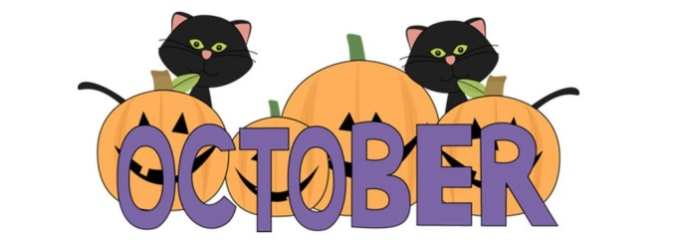
Farmington River Elementary School
October 2019
MONDAY | TUESDAY | WEDNESDAY | THURSDAY | FRIDAY
30  BRUNCH FOR LUNCH  Pancakes  Veggie Sticks w/Ranch Dip  Sausage Links  Sliced Orange Wedges | 1  Cheese Quesadillas  w/Salsa & Sour Cream  Fiesta Corn  Rockin Rice Pilaf  Fresh Fruit | 2  Mighty Meatball Grinders  Fresh Leafy Salad  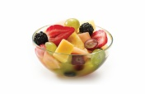  w/Ranch or Italian Dressing  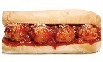  Cheese Sticks  Pretzels  Fresh Fruit Salad | 3  Tyson Chicken Tenders  Steamed Broccoli  Sweet Cornbread  Fruit Medley | 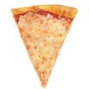  4  Puffs Pizza  Fresh Leafy Salad  w/Ranch or Italian Dressing  Roasted Chick Peas  Sliced Melon
7  Fun Shaped Fish Sticks  w/Tartar Sauce  Crazy Cole Slaw  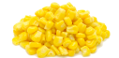  Oven Roasted Sweet Potatoes  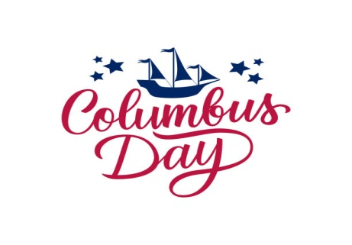  Applesauce | 8  Farmington Franks  Baked Beans  Sweet Steamed Corn  Applesauce | 9  Chicken Noodle Soup  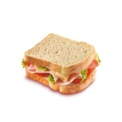  Celery Sticks w/Ranch Dip  Saltine Crackers  Cheese Sticks  Fresh Fruit Salad | 10  Ham-N-Cheese Sandwich  Veggie Sticks w/Ranch Dip  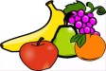  Pretzels  Fresh Fruit | 11  Puffs Pizza  Fresh Leafy Salad  w/Ranch or Italian Dressing  Tortilla Chips  Sliced Melon
14  NO SCHOOL | 15  Cheese Ravioli  Fresh Leafy Salad  w/Ranch or Italian Dressing  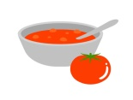  Garlic Bread  Fruit Medley | 16  Glorious Grilled Cheese  Toms Tomato Soup  Veggie Sticks w/Ranch Dip  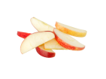  Saltine Crackers  Apple Wedges | 17  Crunchy Beef Tacos  Lettuce & Tomatoes  Salsa & Sour Cream  Rockin Rice Pilaf  Orange Wedges | 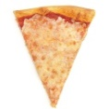  18  Puffs Pizza  Fresh Leafy Salad  w/Ranch or Italian Dressing  Hummus w/Tortilla Chips  Sliced Melon
21  Whole Grain Bagels  Cream Cheese/Butter/Jelly  Veggie Sticks w/Ranch Dip  Cheese Sticks  Yogurt Parfaits  Fruit | 22  Baked Chicken  Steamed Green Beans  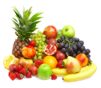  Mashed Potatoes  Bread Sticks  Fruit Medley | 23  Spaghetti & Meatballs  Fresh Leafy Salad  w/Ranch or Italian Dressing  Garlic Bread  Fresh Fruit Salad | 24  Toms Turkey Sandwich  Minestrone Soup  Saltine Crackers  Pretzels  Fresh Fruit Salad | 25  Puffs Pizza  Fresh Leafy Salad  w/Ranch or Italian Dressing  Tortilla Chips  Sliced Melon
28  BRUNCH FOR LUNCH  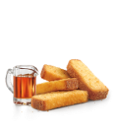  French Toast Sticks  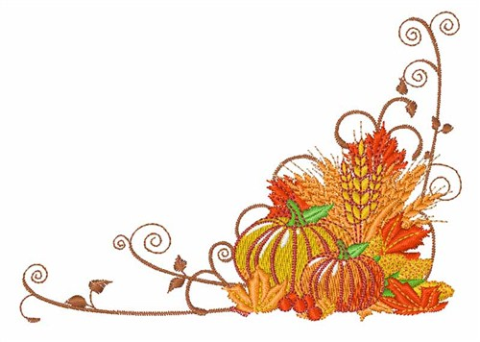  Veggie Sticks w/Ranch Dip  Sausage Links  Orange Wedges | 29  All-American Burger  Baked Beans  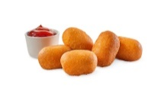  Oven Roasted Potatoes  Fruit Medley | 30  Mini Turkey Corn Dogs  Steamed Broccoli  Rockin Rice Pilaf  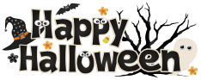  Fresh Fruit | 31  Pumpkins Popcorn Chicken  Black Cats Carrot Coins  Batty Corn Bread  Fresh Flying Fruit | 1  Puffs Pizza  Fresh Leafy Salad  w/Ranch or Italian Dressing  Tortilla Chips  Fresh Fruit
1 % Milk & Fat Free Chocolate Milk available for lunch & breakfast.
Alternate Lunch: Salad, PBJ, Tuna or Egg Salad Sandwich
Student Prices – Breakfast: $1.55 ~ Reduced $0.30 - Lunch: $2.75 ~ Reduced $0.40
Accommodations can be made for students with dietary needs.
FRRSD does not discriminate on the basis of race, color, national origin, sex, age, or disability.

